**CRUD OPERATIONS (Create, Read, Update, Delete) Samuel Okwalinga**

These are the four functions that are considered necessary to implement a persistent storage application[1]. Data is stored in databases and organized in either a relational/ non-relational format e.g. MongoDB[2] as an example of a non-relational database.

**Two categories:**

1. Read Operations: find and return documents stored within your MongoDB database.
2. Write Operations: insert, modify, or delete documents in your MongoDB database.

**NOTE:** Compound operations[3] are kind of hybrid operations that combine read and write operations in a single atomic statement such that both operations take place in the same line of code from the perspective of the client application.

## Create Operations

Create or insert operations add new [documents](https://docs.mongodb.com/manual/core/document/#bson-document-format) to a [collection](https://docs.mongodb.com/manual/core/databases-and-collections/#collections). If the collection does not currently exist, insert operations will create the collection.

MongoDB provides the following methods to insert documents into a collection:

* [db.collection.insertOne()](https://docs.mongodb.com/manual/reference/method/db.collection.insertOne/#db.collection.insertOne)
* [db.collection.insertMany()](https://docs.mongodb.com/manual/reference/method/db.collection.insertMany/#db.collection.insertMany)

In MongoDB, insert operations target a single [collection](https://docs.mongodb.com/manual/reference/glossary/#term-collection). All write operations in MongoDB are [atomic](https://docs.mongodb.com/manual/core/write-operations-atomicity/) on the level of a single [document](https://docs.mongodb.com/manual/core/document/).

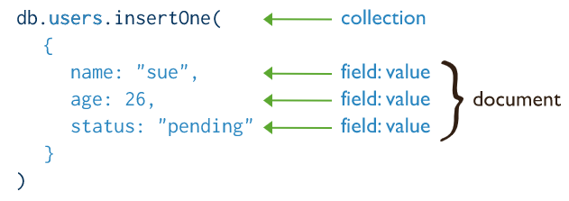

**Read Operations**

Read operations retrieve [documents](https://docs.mongodb.com/manual/core/document/#bson-document-format) from a [collection](https://docs.mongodb.com/manual/core/databases-and-collections/#collections); i.e. query a collection for documents. MongoDB provides the following methods to read documents from a collection:

* [db.collection.find()](https://docs.mongodb.com/manual/reference/method/db.collection.find/#db.collection.find)

You can specify [query filters or criteria](https://docs.mongodb.com/manual/tutorial/query-documents/#read-operations-query-argument) that identify the documents to return.

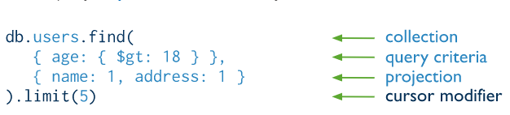

## Update Operations

Update operations modify existing [documents](https://docs.mongodb.com/manual/core/document/#bson-document-format) in a [collection](https://docs.mongodb.com/manual/core/databases-and-collections/#collections). MongoDB provides the following methods to update documents of a collection:

* [db.collection.updateOne()](https://docs.mongodb.com/manual/reference/method/db.collection.updateOne/#db.collection.updateOne)
* [db.collection.updateMany()](https://docs.mongodb.com/manual/reference/method/db.collection.updateMany/#db.collection.updateMany)
* [db.collection.replaceOne()](https://docs.mongodb.com/manual/reference/method/db.collection.replaceOne/#db.collection.replaceOne)

In MongoDB, update operations target a single collection. All write operations in MongoDB are [atomic](https://docs.mongodb.com/manual/core/write-operations-atomicity/) on the level of a single document.

You can specify criteria, or filters, that identify the documents to update. These [filters](https://docs.mongodb.com/manual/core/document/#document-query-filter) use the same syntax as read operations.

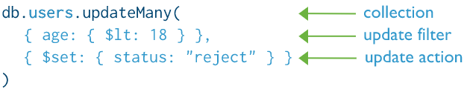

## Delete Operations

Delete operations remove documents from a collection. MongoDB provides the following methods to delete documents of a collection:

* [db.collection.deleteOne()](https://docs.mongodb.com/manual/reference/method/db.collection.deleteOne/#db.collection.deleteOne)
* [db.collection.deleteMany()](https://docs.mongodb.com/manual/reference/method/db.collection.deleteMany/#db.collection.deleteMany)

In MongoDB, delete operations target a single [collection](https://docs.mongodb.com/manual/reference/glossary/#term-collection). All write operations in MongoDB are [atomic](https://docs.mongodb.com/manual/core/write-operations-atomicity/) on the level of a single document.

You can specify criteria, or filters, that identify the documents to remove. These [filters](https://docs.mongodb.com/manual/core/document/#document-query-filter) use the same syntax as read operations.

## 

## Bulk Write

MongoDB provides the ability to perform write operations in bulk.

**Compound Operations**

Three major compound operations (built-in methods) in MongoDB exist:

* [findOneAndDelete()](http://mongodb.github.io/node-mongodb-native/3.5/api/Collection.html#findOneAndDelete) matches multiple documents to a supplied query and removes the first of those matched documents.
* [findOneAndUpdate()](http://mongodb.github.io/node-mongodb-native/3.5/api/Collection.html#findOneAndUpdate) matches multiple documents to a supplied query and updates the first of those matched documents using the provided update document.
* [findOneAndReplace()](http://mongodb.github.io/node-mongodb-native/3.5/api/Collection.html#findOneAndReplace) matches multiple documents to a supplied query and replaces the first of those matched documents using the provided replacement document.

**CRUD HANDLERS**

A handler**[4]** is code that's associated with and triggered by the occurrence of a specific event, like an incoming message, a thrown exception, a signal sent to a process, a network I/O request completing, or a mouse click on a user interface element..

Examples:

* Event handler - Receives and digests events and signals from the surrounding system (e.g. OS or GUI).
* Memory handler - Performs certain special tasks on memory.
* File input handler - A function receiving file input and performing special tasks on the data, all depending on context of course.

**KEY TERMS**

|  |  |
| --- | --- |
| Persistent storage application[5] | Retains data even after the device is powered off. |
| Data[6] | Data is a representation of facts such as numbers, concepts, or instructions in a formalized manner, which should be suitable for communication, interpretation, or processing by human or electronic machine. Also categorized into Qualitative data is descriptive information (it describes something) and Quantitative data is numerical information (numbers) which can also be either discrete (number of items in a list) or continuous (time measurement). |
| Database | An organized collection of data that may be viewed and/or modified. Many types exist e.g. hierarchical databases, graph databases, object-oriented databases, relational databases, non-relational databases e.t.c. |
| Database Management System (DBMS) | A software designed to store, retrieve, define, and manage data in a database. |
| Relational (SQL-sequential) database | Consists of data tabled in rows and columns and connected to other tables with complementary information by a system of keywords that includes primary keys and foreign keys. Examples of Relational DBMS: Oracle Database, Microsoft SQL Server, MySQL. |
| Primary key | A column, or set of columns, whose values uniquely identify each row in the table. |
| Foreign key | A column or group of columns in a relational database table that provides a link between data in two tables. |
| Non-relational [7](NoSQL databases) database | All other forms of databases that are not modeled in a tabular format. Examples of NoSQL databases. the most popular being MongoDB, DocumentDB, Cassandra, Coachbase, HBase, Redis, and Neo4j. Grouped into four: Key-value stores, Graph stores, Column stores, and Document stores. |
| Read Operations | Find and return documents stored within a database. |
| Write Operations | Insert, modify, or delete documents in a database |
| Compound operations | Combine both the read and write operations in a single atomic operation. |
| Create | Allows users to create a new record in a database using for instance the INSERT key word. |
| Read | Allows users to search and retrieve specific records in the table and read their values. |
| Update | Update function is used to modify existing records that exist in the database |
| Delete | Allows users to remove records from a database that is no longer needed |
| Handler[8] | A routine/function/method which is specialized in a certain type of data or focused on certain special tasks. |
| Atomic | Concept of keeping all the related information, which is frequently updated together in a single document using embedded documents |
| Embedded documents | An embedded, or nested, MongoDB Document is a ormal document that's nested inside another document within a MongoDB collection. Embedded documents are particularly useful when a one-to-many relationship exists between documents. |
| API[9] | Application Programming Interface is a computing interface which defines interactions between multiple software intermediaries. |

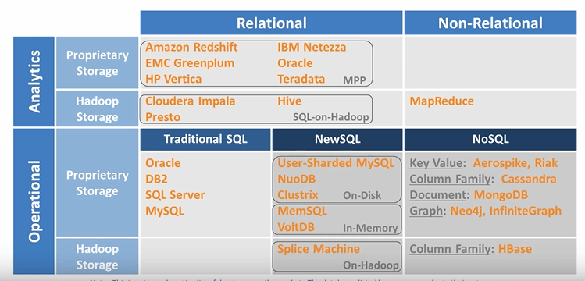**[10]**

1. https://www.sumologic.com/glossary/crud/
2. <https://docs.mongodb.com/drivers/node/fundamentals/crud>
3. <https://docs.mongodb.com/drivers/node/fundamentals/crud/compound-operations>
4. https://stackoverflow.com/questions/195357/what-is-a-handler
5. https://www.sumologic.com/glossary/crud/
6. https://www.mathsisfun.com/data/data.html
7. https://www.jamesserra.com/archive/2015/08/relational-databases-vs-non-relational-databases/
8. https://stackoverflow.com/questions/195357/what-is-a-handler
9. Fisher, S. (1989). ["OS/2 EE to Get 3270 Interface Early"](https://books.google.com/books?id=YToEAAAAMBAJ&q=application+programming+interface&pg=PA6). *Google Books.*
10. https://www.jamesserra.com/archive/2015/08/relational-databases-vs-non-relational-databases/